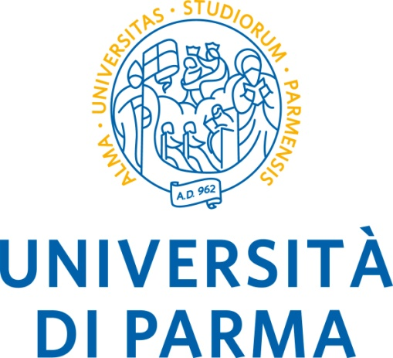

**DIPARTIMENTO DI INGEGNERIA E ARCHITETTURA**



PROGRAMMA DELLA SESSIONE DELL’ 11 DICEMBRE 2020

**I laureandi svolgeranno l’esame in modalità telematica al loro domicilio**

|  |  |  |  |  |  |  |  |  |  |  |  |  |  |  |  |  |  |  |  |  |  |  |  |  |  |  |  |  |  |  |  |  |  |  |  |  |  |  |  |  |  |  |  |  |  |  |  |  |  |  |  |  |  |  |  |  |  |  |  |  |  |
| --- | --- | --- | --- | --- | --- | --- | --- | --- | --- | --- | --- | --- | --- | --- | --- | --- | --- | --- | --- | --- | --- | --- | --- | --- | --- | --- | --- | --- | --- | --- | --- | --- | --- | --- | --- | --- | --- | --- | --- | --- | --- | --- | --- | --- | --- | --- | --- | --- | --- | --- | --- | --- | --- | --- | --- | --- | --- | --- | --- | --- | --- |
| **Commissione Presieduta dal**  **Prof. Fabio Bozzoli**  LAUREA INGEGNERIA MECCANICA TRIENNALE  TESI COMPILATIVE SOLO PROCLAMAZIONE  ore 9:00   |  |  | | --- | --- | | ARRIU | LAURA | | BOCCHI | PIERLUIGI | | BURUIANA | ALEXANDRU | | CICCARELLI | PAOLO | | FOGANG MECHESSOP | JUDITH | | MASARATI | FEDERICO | | NDJOCK | MARTIN | | POMA | GIUSEPPE | | PONZI | MATTEO | | RENAMY | YANN STEPHANE | | SERVENTI | ANDREA | | SOKOL | ANDREA | | UGOLOTTI | GIOVANNI | | VALENTI | ALESSANDRO | | **Commissione Presieduta dal**  **Prof. Fabio Bozzoli**  LAUREA INGEGNERIA MECCANICA TRIENNALE  LAUREANDI CON TESI SPERIMENTALE  ore 09:30   |  |  | | --- | --- | | AVVENTURIERI | MARCO | | BERTOLI | LEONARDO | | BO | VALENTINA | | CAPONE | LORENZO | | CARLOTTI | FRANCESCO | | CARPANA | NICOLA | | CATELLANI | NICOLA | | ILLICA MAGRINI | MICHEL | | MARCHIGNOLI | ALESSIA | | MONTANARI | LUCA | | MURATORE | VINCENZO ANDREA | | PUTINTEV | MIHAIL | | SANTI | LORENZO | | TESTA | SIMONE | | VARRECCHIA | RAFFAELE | | ZECCA | DAVIDE | |